Buy Aged Gmail Accounts – 100% Verified & Phone Verified (PVA). Perfect for business, marketing, or personal use. Fast delivery guaranteed by TopSellerIT. Need trusted, old Gmail accounts? We offer bulk PVA aged Gmail accounts for business, marketing, or personal needs. Verified, secure, and delivered fast from TopSellerIT.com.

Details of Our Gmail Accounts

✔ Phone-verified accounts

✔ PVA, Bulk, Fresh, and Aged Gmail Accounts

✔ Very Cheap Price

✔ Fully completed Profiles

✔ Mostly USA, UK, CA, AUS Profile With English Name

✔ 2008 to 2022 old Gmail is Available

✔ Any country’s Accounts are Available

✔ Money-Back Guarantee

✔ Instant Delivery within 72 hours

✔ 100% Satisfaction & Replacement Guarantee

If you want to know more information, contact us –

24 Hours Reply/Contact

➤Email: topsellerit0@gmail.com

➤Telegram: @topsellerit

➤WhatsApp: +1 (224) 626-2565



# **Buy Old Gmail Accounts**

In today’s digital world, establishing a credible online presence is more important than ever. Whether you’re an entrepreneur seeking to expand your reach or someone looking for reliable [**email accounts**](https://topsellerit.com/product/buy-verified-paypal-accounts/) for personal use, old Gmail accounts can be a game-changer. But with so many options out there, how do you ensure you’re making the right choice? That’s where we come in. Welcome to the ultimate guide on buying old Gmail accounts—everything you need to know about why they matter and how topsellerit.com can help you secure authentic ones without hassle. Let’s dive into what makes these aged accounts essential for anyone aiming to enhance their online experience!

## **What Are Old Gmail Accounts?**

****Old [**Gmail accounts**](https://topsellerit.com/product/buy-linkedin-accounts/) are email addresses that have been created and used for a significant period. They often come with established histories, meaning they may have accumulated contacts, messages, and even some level of trustworthiness in the eyes of various online platforms.

These accounts can be valuable assets for those looking to enhance their digital footprint. Older accounts tend to bypass certain restrictions imposed on newer ones, like limits on sending emails or accessing specific features.

Additionally, many users prefer old Gmail accounts because they often reflect authenticity. An older account is less likely to raise red flags during verification processes compared to a freshly minted one.

For marketers and businesses alike, possessing an aged account can open doors to improved engagement and credibility across different channels.

## **How to verify a Gmail account?**

Verifying a [**Gmail account**](https://topsellerit.com/product/buy-outlook-email-accounts/) is crucial for ensuring its authenticity. Start by logging into the account you wish to verify. If prompted, follow the on-screen instructions to confirm your identity.

One common method involves receiving a verification code via SMS or an alternate email address linked to the account. Make sure you have access to these recovery options for seamless verification.

You can also look at account activity and settings. Check if there are any unusual logins or changes made recently. A legitimate old Gmail account should show consistent activity over time.

Additionally, consider using Google’s security checkup tool. This feature helps assess whether your account has been compromised and allows you to update important security settings.

Always stay alert for phishing attempts during this process, as scammers might try tricking you into revealing sensitive information under the guise of verification requests.

## **How can I buy real Old** [**Gmail Accounts**](https://topsellerit.com/product/buy-verified-wise-accounts/) **from topsellerit.com?**

Buying real old Gmail accounts from topsellerit.com is a straightforward process. Start by visiting the website and exploring their offerings.

You’ll find various packages tailored to different needs. Choose one that suits your requirements best, whether it’s for marketing, business outreach, or personal use.

Once you’ve selected your package, add it to your cart. The site provides secure payment options for a seamless transaction experience.

After completing the purchase, you’ll receive access details promptly via email. Make sure to check your spam folders just in case.

Additionally, topsellerit.com offers customer support if you have questions during the buying process. This ensures you’re not alone as you navigate through purchasing older accounts with confidence.

## **Can you buy fully Old Gmail Accounts?**

Yes, you can purchase fully old [**Gmail accounts**](https://topsellerit.com/product/buy-verified-binance-accounts/). Many providers specialize in selling verified accounts that have been created years ago. These accounts often come with established histories and are less likely to face restrictions.

An older account typically has a higher trust level among various platforms. This makes it useful for marketing, social media management, or any online activities where credibility matters.

However, the key is sourcing from reputable vendors. Not every seller offers genuine old Gmail accounts; some might sell fake or compromised ones. Hence, due diligence is crucial before making a purchase.

When considering such transactions, think about your specific needs as well—whether you’re looking for bulk purchases or just one account will influence your decision on where to buy.

## **Why do you like our Old Gmail Accounts?**

Our Old Gmail Accounts stand out for several compelling reasons. First, they come with a rich history, making them more trustworthy in the digital landscape. Many platforms favor accounts that have been active for years, enhancing your credibility.

The age of these accounts also provides you access to features and services that newer ones might lack. This gives you an edge when navigating online spaces.

Moreover, our Old Gmail Accounts are carefully verified. You can be confident that what you’re getting is genuine and functional. We prioritize quality over quantity.

Customer support is another vital aspect. If you encounter any issues or have questions, our dedicated team is always ready to assist you without delay.

Flexibility plays a significant role as well. Whether for personal use or business needs, these accounts adapt seamlessly to your requirements.

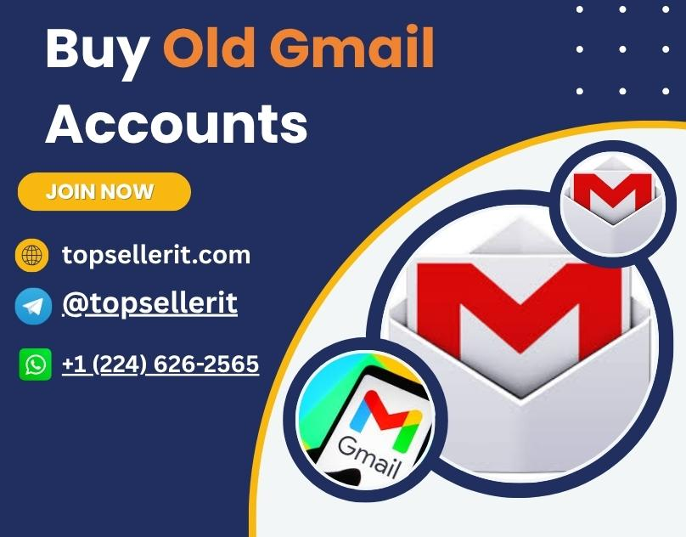

## **Why choose us to Buy Old Gmail Accounts?**

When you choose us for buying old Gmail accounts, you’re opting for reliability. Our extensive experience in the market ensures that every account meets high-quality standards.

We prioritize security and authenticity. Each account is verified to guarantee it’s genuine and functional, giving you peace of mind.

Our customer support team is always ready to assist. Whether you have questions or need guidance, we are just a message away.

Affordability is another key aspect. We offer competitive pricing without compromising on quality.

Flexibility sets us apart, too. You can select from various packages tailored to fit your specific needs, whether you’re an individual or a business owner.

With us, you’re not just purchasing an email account; you’re investing in a tool that enhances your online presence efficiently and effectively.

## **Benefits Of Old Gmail Accounts**

[**Old Gmail accounts**](https://topsellerit.com/product/buy-verified-paypal-accounts/) offer several advantages that can enhance your online experience. For starters, they often have a rich history, which can be beneficial for establishing credibility on various platforms.

These accounts are less likely to be flagged as spam due to their age and activity level. This aspect is crucial for anyone looking to engage in marketing or communication efforts without facing unnecessary hurdles.

Additionally, older accounts typically come with more available features and settings that might not be present in newly created ones. Users benefit from enhanced security measures built over time.

Having an old Gmail account also allows access to valuable data accumulated through years of use, making it easier to manage contacts and important information efficiently. This convenience cannot be understated when you rely on email for personal or business tasks.

## **Additional Information**

When considering the purchase of old Gmail accounts, it’s essential to gather as much information as possible. Understanding the age and activity level of each account can play a significant role in its reliability and usefulness.

Ensure that any provider offers detailed insights into their accounts. This includes history, verification status, and usage patterns.

Additionally, look for customer reviews or testimonials about the service you’re interested in. Real experiences can provide invaluable insight into quality and trustworthiness.

Pay attention to privacy policies as well. A reputable seller will prioritize your data security and explain how they protect your personal information during transactions.

Consider potential support options after your purchase. Access to customer service can be crucial if you encounter issues with your new accounts down the line.

## **Is it safe to buy Old Gmail Accounts?**

When considering whether it’s safe to buy old Gmail accounts, several factors come into play. Security is paramount in today’s digital landscape. Old accounts often carry established credibility, making them more valuable for various purposes.

However, one must tread carefully. The source of the purchase matters significantly. Reliable sellers prioritize user safety and transparency regarding their products.

Buying from reputable websites like topsellerit.com can mitigate risks associated with account ownership changes. Always look for customer reviews and testimonials before making a decision.

Additionally, ensure that privacy policies are clear to protect your personal information during transactions.

Knowledge about how these accounts were acquired also plays a role in ensuring their legitimacy and security for future use.

## **So, how can you understand which are real or fake?**

Identifying real versus fake old Gmail accounts requires a keen eye. Start by checking the account’s age. Genuine old accounts will typically show years of activity.

Look for signs of verification, like recovery options and linked phone numbers. Authentic accounts often have these features set up to ensure security.

Next, examine the email’s usage history. Real accounts usually exhibit consistent interaction over time—sending and receiving emails, subscriptions to services, or social media links.

Also, assess the profile details. Fake accounts might lack personal information or contain generic usernames with random combinations of letters and numbers.

Consider asking for proof from sellers. Reliable vendors will provide screenshots showing account settings or past activity as evidence of authenticity before you proceed with your purchase.

## **Why do you need to buy Old Gmail Accounts?**

Old Gmail accounts offer a range of advantages that can enhance your online presence. With age comes credibility; these accounts often have established reputations, making them more reliable for various uses.

If you’re looking to promote a business or service, using an older account can provide better deliverability rates when sending emails. This helps ensure that important communications reach their intended audience without getting lost in spam filters.

Moreover, seasoned accounts are less likely to face restrictions from Google. They come with a history and often bypass the limitations imposed on newer accounts.

For marketers, old Gmail accounts can aid in social media management and automation tasks without raising red flags. Their longevity provides added security against sudden bans or suspensions.

In today’s digital landscape, investing in old Gmail accounts is not just practical but strategic for anyone wanting to build trust and maintain stability online.

## **Why are we the best to buy Old Gmail Accounts?**

At topsellerit.com, we take pride in being the premier source for Old Gmail Accounts. Our commitment to quality sets us apart from competitors. Each account is thoroughly vetted and verified, ensuring you receive authentic profiles that can withstand scrutiny.

We understand the importance of reliability. With years of experience in this niche market, we’ve built a reputation for providing accounts that remain active and functional. This means fewer headaches for you in the long run.

Customer satisfaction is at our core. Our dedicated support team is always ready to assist with any inquiries or issues you may encounter during your purchase journey.

Our competitive pricing makes it possible for anyone to access premium Old Gmail Accounts without breaking the bank. We believe everyone deserves reliable tools to enhance their online presence, which drives our mission forward each day.

## **FAQs**

When considering the purchase of old Gmail accounts, several questions may arise. Here are some common inquiries:

What is an old Gmail account?  
An old Gmail account refers to a Google email address that has been active for several years. These accounts often come with established credibility and history.

How can I verify a Gmail account?  
You can verify a Gmail account by logging in and checking if it meets your requirements. Look for activity like sent emails or contacts that confirm its age.

Can you buy fully functional old Gmail accounts?  
Yes, purchasing fully functional old Gmail accounts is possible through reputable sellers like topsellerit.com.

Why should I consider buying from topsellerit.com?  
Topsellerit.com specializes in providing real, aged accounts at competitive prices while ensuring customer satisfaction and secure transactions.

Are there any benefits to using older email addresses?  
Older email addresses tend to have higher trust levels among online platforms, making them ideal for various purposes such as marketing or account creation on different websites.

Is it safe to purchase these accounts?  
Safety depends on where you buy them from. Trusted sources like topsellerit.com ensure legitimate transactions without compromising your security.

How do I differentiate between real and fake accounts?  
Look for seller reviews, ask about verification processes, and check if they provide guarantees for their products.

Why might someone need an old Gmail account?  
People often seek older accounts for marketing campaigns, social media management, or simply to enhance their online presence with credible credentials.

Buying old Gmail accounts offers numerous advantages when sourced properly. Always prioritize safety and reliability when making such purchases!